IN THE HIGH COURT OF ALLAHABAD
Civil Misc. Writ Petition Nos. 71563, 71399, 72823, 72606, 72350, 72750, 72825, 72557, 72555, 72554, 72561, 71580, 72432, 72189, 72326, 72400, 71406, 71566, 72558 of 2011
Decided On: 16.12.2011
Appellants: Lalit Mohan Singh and Others
Vs.
Respondent: State of U.P. and Others
Hon'ble Judges/Coram:
Sudhir Agarwal, J.
JUDGMENT
Sudhir Agarwal, J.
1. In this bunch of more than one and half dozen writ petitions aggrieved by test conducted by Secondary Education Board Allahabad, U.P. (hereinafter referred to as "the Board") termed as "U.P. Teachers Eligibility Test 2011", the petitioners have approached this Court by means of these writ petitions, assailing their failure on various grounds. Some broad issues are as under:
I. Several questions having multiple options were wrong in the sense that none of the options was correct answer to the concerned question.
II. Some of the questions were such where according to model answers subsequently disclosed by examining body, the option disclosed to be correct was actually incorrect. Instead some other answer was correct. Hence, the questions have been evaluated with wrong answers, following mistake committed in model key answers prepared by the Board.
III. The candidates were actually present and had appeared in the examination taut were wrongly shown absent.
IV. More than one candidate were provided same roll number which has influenced their result.
V. Answer booklet of one series had been examined with model answer sheets of different series resulting in wrong evaluation/assessment of candidates' answer sheets.
There are certain minor individual complaints also with regard to assessment, declaration of result etc.
2. Considering volume of cases coming to this Court raising similar complaints some of which are referred above and magnitude of the test conducted by the Board, this Court found that it would be in the interest of public at large if these matters are disposed of at the earliest and in this view of the matter with the consent of learned counsel for the parties, the Court permitted them to address Court on various aspects based on their averments contained in their respective writ petitions in general.
3. So far as the Board is concerned, learned Standing Counsel chose not to file counter-affidavit and instead had the benefit of presence of Secretary of the Board with relevant information and assisted the Court expressing Board's anxiety also of expeditious disposal of the matter in such a manner so that grievances of the petitioners are attended in an effective and objective manner and all these matters may settle finally. Regarding individual dispute relating to minor mistakes in assessment of answer sheets it was suggested that the Board shall entertain complaints made by individual candidates specifically and after looking into record and examining threadbare, the candidates shall be informed of the consequences. In this context, the only anxiety expressed by the Board is that this indulgence cannot be allowed for an indefinite period and, therefore, the Court may provide any reasonable time within which candidates aggrieved if any, may approach the Board with their complaints which shall be attended by it. Sri Neeraj Upadhyay, learned Standing Counsel, however, also informed the Court that the Board had already been receiving and attending complaints of candidates and had also examined the same in detail. He also informed that with regard to discrepancies in model key answers the complaints were attended by Board and they constituting a committee of experts who examined all the answer sheets threadbare and thereafter submitted their report. It has been explained by him that there were three sets of examinations namely;
(I) Junior Primary Level Examination (Class I to V) (hereinafter referred to "J.L.E."
(II) Senior Primary Level Examination (Class VI to VIII) (Science) (hereinafter referred to "S.L.E. (S)"
(III) Senior Primary Level Examination (Class VI to VIII) (Arts)(hereinafter referred to "J.L.E. (A)"
He said that in every set of these examinations, answer sheets of four series were circulated to examinees which are Series 'A', 'B', 'C' and 'D'. The total number of questions in one set were 150. Questions set up in all the series of one kind of examination are same but their order/arrangement in different Series is different. For example, in J.L.E. question No. 6 in Series 'A' is question No. 26 in Series 'B', 1 in Series 'C' and 21 in Series 'D' and so on. He said that in J.L.E.'s question paper committee of experts' constituted by Board found that there are five questions in which option shown to be correct in the model key answerers was actually incorrect and instead thereof other options were correct. Similar mistake in respect to eight questions was found in S.L.E. (S) and seven questions in S.L.E. (A). Besides in S.L.E. (S) two questions were such for which none of the options was correct. In S.L.E. (A) there are three such questions in which none of the option was correct. Sri Upadhyay, therefore, submitted that acting upon the aforesaid report of Experts, the Board revised its result by assigning marks to such candidates who had answered correct option (revised) by treating model key answers of that question incorrect and deducting marks allotted earlier. So far as the questions where no option was found correct, in respect thereof, all the candidates have been awarded marks whether they attempted the answer or not and revised result as such has been declared.
4. Details of such questions, where answers, options have been varied or where all answers were incorrect in different Series are as under:
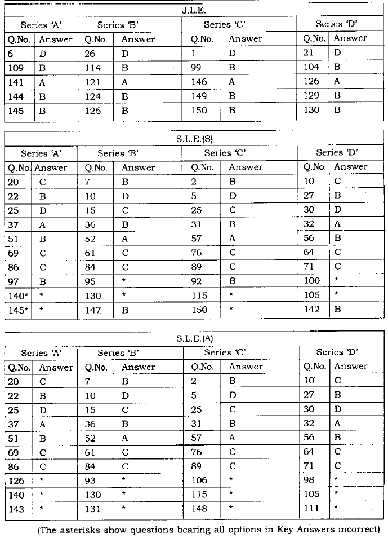
5. Sri Ashok Khare, learned Senior Advocate, appearing in Writ Petition No. 71563 of 2011 contended that in L.J.E., answer sheet, Series 'B' there are three more questions namely, questions No. 21, 85 and 142 in regard whereto either of key answers are incorrect, or the correct answer as per model key answer is incorrect and instead a different answer is correct. These three questions and options given thereto in Series 'B' of J.L.E. are as under:
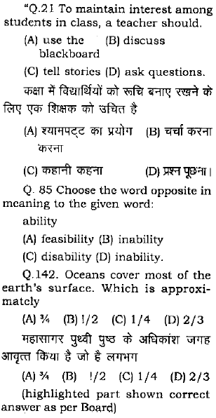
6. He further submitted that question No. 121 has four options and all these options are incorrect. Similarly, with respect of question No. 125 he contended that earlier the model key answer shows option 'C' as correct while as per report of experts committee, the Board has now switched to option 'B' but this is also incorrect option. Therefore, deduction of marks in respect of question No. 125 Series 'B' of such candidates who have opted for 'C' is incorrect.
7. In Writ Petition No. 71399 of 2011 Sri S.K. Shukla, Advocate, advancing his submission on behalf of three petitioners, Sri Jai Prakash Pandey, Sunita Pandey and Harshita Malviya, contended that in J.L.E. Series 'B' questions No. 2, 3 and 28 also have wrong answers in Model Key Answers and instead correct answers ought to be as suggested by petitioners. These three questions read as under:
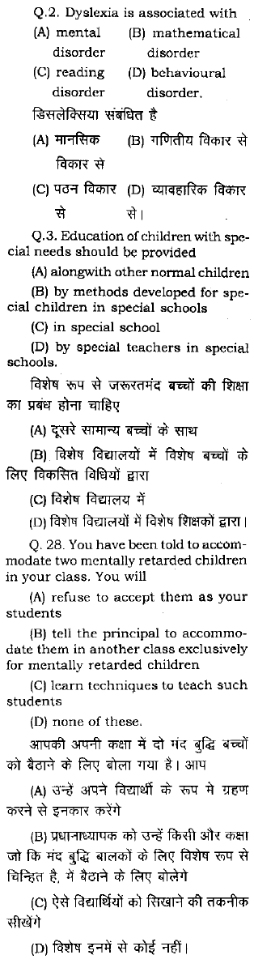
8. Similarly in regard to S.L.E. (A) Series 'B' he submitted that answers treated correct in model key answer in regard to questions No. 3, 17 and 21 are not correct. These questions read as under:
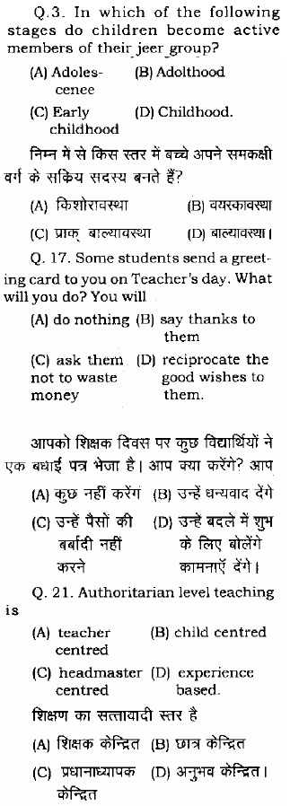
9. In all the remaining matters, learned counsel for the petitioners did not make any individual submissions but adopted and followed what has been argued by learned Senior Advocate Sri Khare and others. Basically, their grievance is that individual errors in respect whereto they have raised their complaints, the Board should be asked to examine and take appropriate decision accordingly.
10. I propose to consider first the arguments with respect to certain questions which according to petitioners are totally wrong or options selected by Board is wrong and how it should be dealt with.
11. Before adverting to rival submissions, this Court has no hesitation in reiterating the well settled exposition of law that in academic matters expert's opinion should not be interfered lightly by a Court of law in judicial review and instead great weightage has to be attached to their opinion. There may be a situation where different experts express different opinions but in such matters, broadly, the stand of examining body should be accepted unless it is found to be palpably wrong and erroneous. It is own case of the Board that in J.L.E. five questions are such where options earlier treated correct by Board were in fact not so and instead another option was correct. Similar is the case in S.L.E. (S) with regard to eight questions and in S.L.E. (A) seven questions.
12. Besides, two questions in S.L.E. (S) and three questions in S.L.E. (A) are such where all the four options are incorrect. With regard to these two and three questions respectively, the Board has taken decision to award marks to all the candidates and for this stand of the Board, learned counsel for the petitioners did not find any objection, hence, so far as this aspect is concerned, it warrants no consideration by this Court.
13. The Court is concerned with questions where instead of option earlier shown correct by the Board, they have changed their view and another option has been treated to be correct. What the Board has done is that all the candidates who have answered revised option, the Board has awarded marks to them and option declared earlier correct but now incorrect, the marks awarded in respect thereof have been deducted. To my mind this approach of the Board to some extent has done more injustice. The Teachers Eligibility Test is a qualifying test without which a candidate would not be eligible for appointment as Assistant Teacher in Primary School in view of Regulations framed by the National Council for Teachers Education (hereinafter referred to as "NCTE") in exercise of power under Section 23 of Right of Children to Free and Compulsory Education Act, 2009 (in short "Act, 2009").
14. The general candidates securing 60% and above marks and reserved category candidates securing 55% and more marks are to be declared successful. It is per se not a competitive test. Inclusion of one shall not necessarily result in exclusion of another. If a candidate has already been declared successful on the basis of answers to respective questions in which options have now have been altered by the Board, and, on the basis of awarding of such marks he has been declared successful it would be unjust to declare him unsuccessful now if due to deduction of marks of such questions, the total marks secured by him earlier become lower than the prescribed pass marks. In my view the revised opinion of the Board in respect of such questions should not affect the result of candidates who have already been declared successful and they should remain untouched. The process adopted by the Board is basically in the nature of corrective steps and if that be so, it ought no to have acted prejudicial to the candidates already declared successful merely on account of revised opinion with regard to options which were earlier treated correct.
15. Coming to the submission that in JLE there are some questions which are palpably incorrect or options determined by the Board to be correct is still incorrect. I proceed to examine whether it can be said that the Board's decision is ex facie incorrect and arbitrary or not.
16. Question No. 21, Series 'B' J.L.E. is, "what should a teacher do to maintain interest amongst the student in a Class". This question forms part of Section I relating to Pedagogy. The dictionary meaning of the word 'Pedagogy' is study of teaching methods. It basically involves knowledge and training, though scientific but philosophical in aspects. Experience of different persons in the field may have some variations. In these circumstances, general practice in such matter is to follow opinion which is widely accepted and the manner in which, most of the Experts treat correct. No mathematical precision can be found. By referring to one or two text books or individual opinion nothing can be said or argued. Unless shown ex facie improbable, the Courts must honour and respect opinion of Expert's and examining body since it is their field of expertise and, therefore, the same must be given due honour. This is a question based on experience and subjective opinion of Experts who may differ. The Board has provided option 'D' as the correct answer and it cannot be said that it is palpably erroneous or faulty. Where two views are possible the opinion of Experts on the subject and the examining body must be given due credit, respect and deserved preference. I, therefore, find no reason to accept submission of Sri Ashok Khare in regard to Question No. 21 Series 'B', J.L.E.
17. Question No. 85, Series B, J.L.E. asked opposite of 'Ability'. The Board finds correct option as 'D'. Sri Khare submitted that even 'disability' is correct answer. In this question, in fact, according to Sri Khare, there are two options which are correct i.e., 'disability' and 'inability'. Learned counsel for the petitioner tried to rely on certain legal dictionaries' meanings in this regard. I find no force.
18. 'Disability' and 'inability' do not carry the same meaning though to some extent the consequences may be the same. The term 'disability' is defined in New Lexicon Webster's Dictionary of the English Language 1987 Edition at page 269 as under:
Disability: a being physically or mentally disabled; a cause of this; a legal disqualification or incapacity.
Similarly, 'inability' is also therein at page 488 as under:
Inability: The state or quality of being unable
19. In Oxford Advanced Learner's Dictionary, 7th Edition 2005 defines 'Disability' at page 430 as under:
Disability: A physical or mental condition that means you cannot use a part of your body completely or easily, or that you cannot learn easily.
20. It also defines 'ability' at page 2 and 'inability' at page 782 as under:
Ability 1. (Singular)--to do something, the fact that somebody/something is able to do something. Opp: Inability. 2. a level of skill or intelligence
Inability (to do sth) the fact of not being able to do something;
21. Terms or words as explained by Law Courts in the context of some statute etc. are not to be relied to create confusion that there may be some other answers also. I, therefore, find no palpable error on the part of the Board in treating option 'D; in question No. 85 Series 'B', J.L.E. to be correct answer. The argument raised otherwise is rejected.
22. Question No. 121, Series 'B', J.L.E. really poses a serious problem. It asks about an International Organization which looks after "environmental protection all over the world". The options of question No. 121 are: (A) WWF (B) WHO (C) PETA (D) UN. The Board has treated option 'A' i.e., WWF (World Wildlife Fund) as the correct answer. I have serious doubt about this. Rest two options namely, 'B' and 'C admittedly have no connection with the environment. The basic object and mission of WWF is to conserve nature and reduce the most pressing threats to the diversity of life on earth. It deals with protection of wildlife throughout the world and is not concerned mainly with environment though forest may constitute a part of environment. To any person of common prudence, the question is apparently difficult to answer from the options given thereunder. It is true that out of four options, 'A' would have gone nearest to the answer, but it cannot be said to be totally correct answer as such. United Nations Environment Programme is an organization of United Nations dealing with environment and its development. However, since out of four options, two options namely, WHO and PETA are clearly and palpably inapplicable, and WWF, to some extent is concerned with nature which includes environment, the candidates by process of elimination could have rejected other except 'A'. Looking from this angle, determination of option 'A' correct by itself may not be palpably wrong and incorrect. This could have led me in refraining from interfering with the decision taken by Board by treating option 'A' correct provided this decision would have been taken initially by the Board also. The Board has however, admitted that in the model key answers it has treated another answer correct which it has not disclosed. The same has now been changed after report of Experts' committee to Option 'A' meaning thereby options were so confusing and vague that earlier even examining committee, who set the paper also committed a mistake. This shows that question and answers are so vague that even experts failed to find out correct option at one point of time. In such a case, no candidate should be made to suffer. Hence in my view this question should be treated to be a wrong question having no correct answer. Therefore, marks in respect of question No. 121, Series 'B' J.L.E. shall be allotted to all the candidates treating this question wrong in its entirety. This direction shall simultaneously apply to the corresponding questions in remaining series namely, A, C and D in J.L.E.
23. Now I come to Question No. 125 Series 'B' J.L.E. It talks of most popular species of sea turtles found in the Waters of Indian sub continent. According to Board's own stand, earlier it has treated some other option correct but by virtue of revised option pursuant to experts committee report has switched over to option 'B' Series 'B' i.e., 'Loggerhead'. According to petitioners the correct answer is option 'C' i.e., "Olive Ridley". In support of their submission, petitioners have placed reliance on certain information downloaded from internet. At page 99 one of the downloaded information placed by petitioner before this Court says, "Olive Ridley Turtle" is considered a most abundant Sea Turtle in the world with an estimated 800,000 nesting female annually. About the "Loggerhead Sea Turtle" at page 104 it reads as under:
Habitat: Prefer to feed in coastal bays and estuaries, as well as in the shallow water along the continental shelves of the Atlantic, Pacific and Indian Oceans.
24. The Board's Experts initially did not choose 'Loggerhead' as the correct option but it has been taken in the revised opinion. About 'habitat' of "Olive Ridley", page 100 of writ petition No. 71563 of 2011 shows that it is globally distributed in tropical regions of South Atlantic, Pacific and Indian Oceans. At page 100 about "Olive Ridley" it further says "In the Northern Indian Ocean, arribadas occur on three different beaches along the coast of India". Exact population of both these categories of turtles in waters of Indian Sub-continent is not mentioned but at page 101 in writ petition No. 71563 of 2011 published record says that in 1970s numerous Olive Ridley deaths were reported in Eastern Indian Ocean. The question ex facie appears to be quite confusing and vague inasmuch as, it contains two options over which the readers can lay their claim that both may constitute correct answer. Here examinees are not expert Scientists or environmentalists or in that way, Scientists in Flora and Fauna. These candidates are aspiring to become Assistant Teacher in Primary School, i.e., the first stage of education. Extraordinary scientific information with extensive details cannot be accepted from these persons. The questions ought to have been set in these examinations commensurating to the standard of the candidates who are expected to appear in the concerned test. In that context the question appears to be quite confusing, vague, having multiple correct answers. However, these is no dispute in this matter that rest of the two options given in Question No. 125 are apparently wrong. It is this situation which refrained me from declaring this entire question, incorrect. In the circumstances, in my view, both the options 'B' and 'C' ought to be treated correct and candidate who have answered either of the two should be given due credit and awarded marks. I answer accordingly.
25. Question No. 142, Series 'B', J.L.E. Again poses a more serious problem. It asks the "extent of coverage of earth surface approximately by oceans". It does not talk of mere 'water' but is confined to 'oceans'. The coverage by Ocean is lesser than water as a whole. The Court is informed that the Board treated option 'A' as correct answer. Learned counsel for petitioner tried to show that actual area covered by oceans comes to about 70.8 per cent which is a mid way figure between 2/3 and 3/4, i.e. 66.6 per cent and 75 per cent. These figures could not be disputed by the respondents. Hence, in my view, the Board in this question should treat option 'D' also correct and candidates who have answered either of options i.e. 'A' and 'D' in series 'B', Question 142 in J.L.E. should be awarded marks.
26. So far as questions No. 2, 3, 28 of Booklet 'B' J.L.E. And 3, 17 and 21, Series 'B' S.L.E. (A) are concerned, as argued in writ petition No. 71399 of 2011, I find that these questions are in the subject of Pedagogy. As already said, if Experts and the examining body have decided and opined a particular option to be correct, unless that option is shown to be palpably incorrect, no interference is called for in judicial review. It is the decision of Experts in the subject which must be honoured unless it is shown to be totally perverse. Hence, I find no irregularity in these questions.
27. So far as other aspects are concerned, i.e., alleged mistakes committed in assessment of copies, duplicate roll number etc., I do not find it expedient and appropriate to make any intervention at this stage, since Sri Neeraj Upadhyay, learned Standing Counsel has stated at the Bar that Board shall look into such grievances of candidates if appropriate application is submitted to the Board within a prescribed time as deemed proper by this Court, and the matter shall be examined and decided at the level of the Board. In the facts and circumstances, in view of discussion made above, I dispose of these writ petitions with the following directions:
(I) Question No. 121, Series 'B', J.L.E. contain all wrong options and, therefore, it shall be treated a wrong question. Consequently the marks in respect of Question No. 121, Series 'B', J.L.E. shall be allotted to all candidates who have appeared in the concerned test. This direction shall simultaneously apply to corresponding question in remaining Series namely, 'A', 'C' and 'D' in J.L.E.
(II) In respect of Question No. 125, Series 'B' JLE, the candidates answering any of the options i.e., 'B' or 'C' shall be awarded marks. This direction shall simultaneously apply to corresponding question in remaining Series namely, 'A', 'C' and 'D' in J.L.E.
(III) In respect of Question No. 142, Series 'B' JLE, the candidates who have answered any of the options i.e., 'A' or 'D' shall be awarded marks. This direction shall simultaneously apply to corresponding question in remaining Series namely, 'A', 'C' and 'D' in J.L.E.
(IV) Revised opinion of the Board with respect to Questions shown in the charts in para 5 above (other than asterisk marked) shall not affect adversely the result of the candidates already declared successful merely for the reason of change of opinion of the Board vis a vis correct option.
(V) All the candidates who have attempted these questions and have answered by referring to one of the two options, namely, the one which was correct as per initial Model Key Answer or that which is now correct as per the revised opinion, the candidates in both the events shall be awarded marks and their result shall be prepared accordingly.
(VI) The Board shall publish a notice at least in four newspapers of different languages having wide circulation at the State level informing all concerned that in case any candidate has any grievance regarding UPTET Examination, 2011, about assessment etc., he may register his complaint by submitting application alongwith process fee of Rs. 100/- per application (by cash or by demand draft) within 15 days from the date of publication in the newspapers.
(VII) The Board shall entertain all applications of the candidates raising their grievance regarding assessment etc. and shall look into their grievance and take a decision thereon within a week from the date of receipt of such application. Such decision shall be communicated to the candidate concerned within a week thereafter either by placing information on internet or on mail address given by the candidate or by registered post.
(VIII) The candidates who are already declared successful, their result shall not be affected to their prejudice
but in case in view of the directions give above regarding certain questions, if their marks are to be increased, the same shall be given due credit.
(IX) The revised result as a consequence of compliance of above directions shall be uploaded on internet and shall be given due publicity at the earliest.
(X) No costs.

